Improving client relationship skills
Co-sponsored by
Amsterdam Centre on the Legal Professions and Access to Justice, University of Amsterdam
Osgoode Professional Development, Osgoode Hall Law School, York University (Canada)
National Institute for Teaching Ethics & Professionalism (USA)
Saturday, 20 July 2024, University of Amsterdam Law Hub
Address: Nieuwe Achtergracht 164, 1018 WV Amsterdam (ground floor of Amsterdam Law School)

Program:

12:15 – 12:30 Arrival at The Hub, check-in, pick up lunch meal
12:30 – 12:40 Welcome
Prof. dr. drs. Iris van Domselaar
Director, Amsterdam Centre on the Legal Professions and Access to Justice
Tim Verheij
Coördinator, Onderwijs & Rechtshulp – Amsterdam Law Hub
12:40 – 13:00 Workshop overview
Prof. Clark D. Cunnningham, Georgia State University College of Law
Director, National Institute for Teaching Ethics & Professionalism (USA)

13:00 – 13:20 Learning client relationship skills – what Dutch legal aid clinics do

13:20 – 13:50 Simulated Clients – theory and practice
Prof. Paul Maharg, Osgoode Professional Development

13:50 – 14:50 Demonstration and discussion of online simulated client meeting

14:50 – 15:10 Break-out group discussion of possible applications of simulated client methodology in different settings
15:10 – 15:30 Reports from break-out groups and possible next steps

Resources: www.paulmaharg.com/2024/07/08/sim-client-workshop-programme-and-resources/

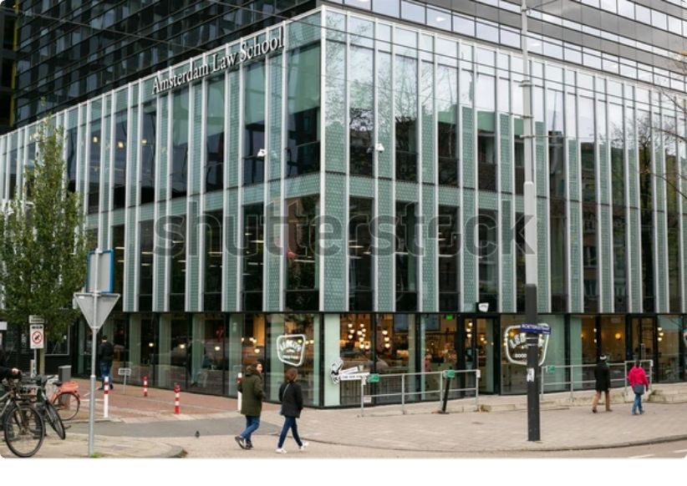 | 