iPad and Legal Learning (iLEGALL)

Jonathan Bainbridge, Paul Maharg, Rebecca Mitchell

1. Summary of iLEGALL project

Context of mobile learning
The argument of this study may be postulated in a number of statements:
- Mobile learning abolishes the fixity of place (class, seating) and time (eg lecture envelope) by teacher and institution. Instead, learners require to establish their own rhythms according to the needs of self and social collaborative group.
- Context for each learner will thus be significantly different, more so than in conventional f2f education. Media design needs to support distributed learning but also social learning, as well as swift and consistent recognition, recall and rehearsal of learning on the part of individuals.
- Such layered experiential context can be understood as a form of music, with its own notation – the inscriptions left by learners.
- Mobile learning will be more social and conversational than in other media (Vavoula et al 2009)
- The ground of the social will not be a separation of mind from social. Rather, as with Dewey’s instrumental form of learning (Dewey 1916), and actor-network theory (Latour 2005), construction of learning in the social environment will be inseparable from our construction of the social.
- A key problem for any technology-supported mobile environment is how to facilitate inscriptions, conversations and social environment such that learners can immerse in tasks that enable transactional learning (Maharg 2007).

Project aims and methods
The main hypothesis of our project is that the barriers to an understanding and adoption of mobile technology in legal education, as in higher education generally, are not technical but social. We further hypothesise that there are two causes: staff are uncertain how to design and implement such technologies; and there is currently too much institutional investment in replication of conventional modes of teaching through the unimaginative use of technologies such as institutional VLEs.

Our project therefore has two aims:
- a preliminary investigation of the inscriptions, conversations and social environment that result from use of a mobile device. This will involve the use of iPads on a pilot project with students on a Business Law & Practice module on the LPC at Northumbria University. We shall issue the devices to students and track use of them over the course of the module. Content will have been substantially rewritten to adapt to a mobile environment and module structure will also be re-designed to align with constructivist and transactional learning principles.

This will involve use of questionnaires, interviews, tracking software and feedback to and discussion with students in research workshops.

- a comparison of the functionality that students use in the mobile environment we shall build for them, with the functionality of the environment currently available to them in the university VLE, eLP (Blackboard). Currently, VLEs such as Blackboard afford very little interaction between students, except on highly constrained applications. There is also little opportunity for students to use PIMs on a professional basis. We shall compare student response to the two environments, presenting them with a conventional eLP environment (effectively the current module) with which they are familiar, and therefore can comment upon, and ask them to compare that environment’s functionality with that of the mobile device.

This will involve use of interviews and feedback to and discussion with students in research workshops.

Student and staff activity
The module represents a significant shift in pedagogy towards the mobile domain, and this has implications for both students and staff. Using the iPad, students will, inter alia:
- Access learning resources such as books, online databases, documents, simulation guidelines and flowcharts, webcasts, quickcasts
- Take part in simulations of legal practice, in particular Business Practice simulations, which will be the focus of group (or ‘firm’) and individual learning and assessment.
- Create, edit and store documents using cloud technologies and social web applications as well as native iPad and iPhone apps.
- Communicate with each other and with staff using email, discussion forums, surgeries and video conferencing; and communicate with sim characters through SIMPLE.

Staff will, inter alia:
- Create learning & assessment resources for student learning; and guidance descriptions of this new approach to learning.
- Create simulations and take part in simulations.
- Give formative feedforward and feedback.
- Appraise summative assessment tasks.
- Communicate with students, in role and as tutors.

Project timeline
A general timeline for project development is attached (see Appendix 1, p.7).

Underlying theory
Our project will adapt mobile learning theory (Sharples, Vavoula), together with Latour’s version of actor-network-theory, and Engeström’s CHAT (cultural historical activity theory) framework (adapted). It will take a constructivist approach to student mobile learning through the implementation of transactional learning (TL). Engeström’s CHAT framework has been adapted as follows (though elaborated, it still follows the typically dialectical movement and structure of the original):

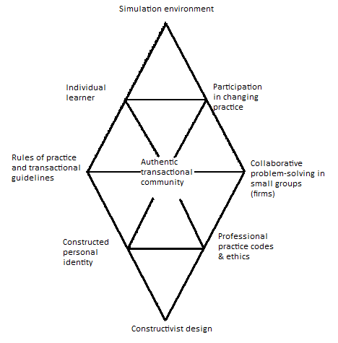
Figure 1: Mediational activity in transactional learning (Barton, McKellar, Maharg 2007)

Apart from the elaboration, what we have done is to adapt CHAT to the process of learning by simulation. There are many aspects of this model of learning that require investigation. In the iLEGALL project there is one triangulation that we wish to explore in detail, and to which the project aims will contribute evidence. This focuses on the meditational role of identity. Most theories of professional identity treat individual identity as being an entity separate from though embedded in the tools and distributed social environments that influence the individual’s identity. However it is a key point in situated learning, as of the adapted CHAT structure above, that identity itself is an integral element of its habitus, not a separate entity within it. The Deweyan focus upon the socially-mediated individual is typical of this inversion. In the diagram above, therefore, before the rules of practice and transactional guidelines (subject) can begin to effect a transactional community (object), they need to be mediated (understood and enacted) through the personal identity of individuals (tool).

Transactional learning, as a design heuristic, operates on a curriculum-design level, involving designers and students in the following activities and states:
active learning
through performance in authentic transactions
involving reflection in & on learning,
deep collaborative learning, and
holistic or process learning,
with relevant professional assessment
that includes ethical standards
In our analysis of project results we shall be investigating these aspects of CHAT theory and TL.

2. Brief literature review
Our study follows the classic literature in actor-network-theory (ANT), together with the mobile learning literature such as created by the MOBILearn Group (O’Malley et al 2003), and created by Mike Sharples and the group at Nottingham University’s Learning Sciences Research Institute. We also dovetail research from Yrjö Engeström, and our own developed pedagogies such as TL. Unlike medical education (Ellaway & Masters 2008), there have been very few serious studies of mobile learning in legal education in any Common Law jurisdiction within the last three years. A literature search 2008-2011 for UK jurisdictions, for Ireland, USA, Canada, Australia, and New Zealand identified no studies that were both theoretical and based upon empirical data within this datespan. Our study can therefore claim to be a unique, timely and much-needed project in the field of legal education.

3. Project outputs
There will be at least four sets of project outputs:

iPad apps
We shall make our portal design and apps available for the wider legal educational community. Information will be available via our Northumbria site and the BILETA websites, and the apps will be available, of course, via iTunes.

SIMPLE sims
The SIMPLE blueprints we create will be available via Simshare (www.simshare.org.uk) under Creative Commons licences. Further information on any plugins will be available from the SIMPLE site at http://simplecommunity.org, from where the plugins can be obtained under the same conditions as SIMPLE itself.

Other learning resources
We shall create other resources to accompany the simulations such as webcasts and podcasts and other textual resources. These will be made available via Simshare on Creative Commons licences. Some of these resources are briefly set out in Appendix 2 as part of the resource plan for the simulations we shall create (p.8).

Research
We shall generate a first-stage report, Creative Commons-copyrighted and posted to the SSRN as well as BILETA websites. We intend to refine this report for publication in at least one journal, taking into account more of the theoretical literature surrounding the concept of mobile learning.

4. Costs and funding
Salary costs of all full-time university employees, together with project infrastructure costs, will be borne by Northumbria University. The purchase cost of the devices will be borne by the Law School. There will be no ongoing support costs: students will own the devices and be responsible for their safety and maintenance. We are therefore seeking funding to cover the following costs:
- Employment of a project manager to manage the day-to-day progress of the project on a temporary part-time basis.
- Employment of technical consultants on a temporary part-time basis to develop small apps for the iPad portal we are designing.

5. Further funding
Funding from Northumbria Law School has been guaranteed, to match BILETA funding requested. We are also seeking funding from institutions, other law schools, other entities including law firms either using or interested in using iPads in their legal practices. Such further funding will be used to further develop the portal interface, with relevant apps; the webcasts and podcasts; and the design and development of plugins to the SIMPLE environment that would allow more streamlined communications between students than is presently possible in SIMPLE sims. With further funding we would also substantially develop the educational research base of the project, and bring in more partners, both nationally and internationally.

6. Project team

Jonathan Bainbridge (Principal Researcher)
Jonathan is Module Leader, previously a practitioner, and a keen proponent of mobile learning. He will be responsible for quality of resources, development of module resources, and ensuring that key milestones are met and that the project is in budget. He will teach the module, have oversight of resources development and implementation, and take part in research design and dissemination of findings.

Professor Paul Maharg
Paul brings to the project a knowledge of the research literature, a knowledge of learning with simulation and digital resources, and curriculum design. He will be on research leave during most of the developmental phase, but will take part in the research design, research gathering, analysis, write-up and dissemination of findings.

Joel Mill (Project Manager, part-time temporary)
Joel is a part-time law student who also works part-time with Apple, and comes from a Further Education and project management background. He will be responsible for day-to-day management of the project not only in development but also in implementation phases.

Rebecca Mitchell
Rebecca is a Principal Lecturer at Northumbria Law School. She will be responsible with Jonathan for development of materials, teaching on the module, for oversight of the supply of iPads, liaison with students, collation of project data and dissemination of findings.

Technical consultants
As appropriate, eg for apps development for the iPad.

7. Contact details of principal researcher
Jonathan Bainbridge, Northumbria Law School.
Email: jonathan.bainbridge@northumbria.ac.uk

8. Contact details of referee:
Ms Karen Barton, Senior Lecturer, Law School, University of Strathclyde.
Email: karen.barton@strath.ac.uk

9. References
Barton, K., McKellar, P., Maharg, P. (2007). Authentic fictions: simulation, professionalism and legal learning, Clinical Law Review, 14, 1, 143-93.
Bekerman, Z., Burbules, N. and Silberman-Keller, D. (2006.) Learning in Places: The Informal Education Reader, New York, Peter Lang.
Dewey, J. (1916/2004). Democracy and Education: An Introduction to the Philosophy of Education. Dover Publications, New York.
Ellawy, R., Masters, K. (2008). AMEE Guide 32: e-Learning in medical education Part 1: learning, teaching and assessment. Medical Teacher, 30(5), 455-73.
Latour, B. (2005). Reassembling the Social. An Introduction to Actor-Network-Theory. Oxford University Press, Oxford.
Maharg, P. (2007). Transforming Legal Education. Learning and Teaching the Law in the Early Twenty-first Century. Ashgate Publishing, Aldershot.
McFarlane, A., Triggs, P. and Yee, W. (2008). 1:1 access to mobile learning devices. Researching mobile learning - Interim report to Becta. Available at: http://partners.becta.org.uk/upload- dir/downloads/page_documents/research/mobile_learning.pdf. Last accessed: 2.2.11.
O’Malley, C., Vavoula, G., Flew, J.P., Taylor, J., Sharples, M., Lefrere, P. (2003) MOBIlearn: WP 4 – Guidelines for Learning/Teaching/Tutoring in a Mobile Environment. Available at: http://www.mobilearn.org/download/results/guidelines.pdf Last accessed: 2.2.11.
Sharples, M., M. Milrad, I. Arnedillo Sánchez and Vavoula, G. (2009). Mobile Learning: Small devices, Big Issues. In: Technology Enhanced Learning: Principles and Products. N. Balacheff, S. Ludvigsen, T. d. Jong, A. Lazonder and S. Barnes,(eds). Heidelberg, Springer: pp 233-249.
Vavoula, G., Pachler, N., Kukulska-Hulme, A. eds. (2009). Researching Mobile Learning: Frameworks, Tools and Research Designs. Oxford, Peter Lang Verlag.

Appendix 1: Project timeline
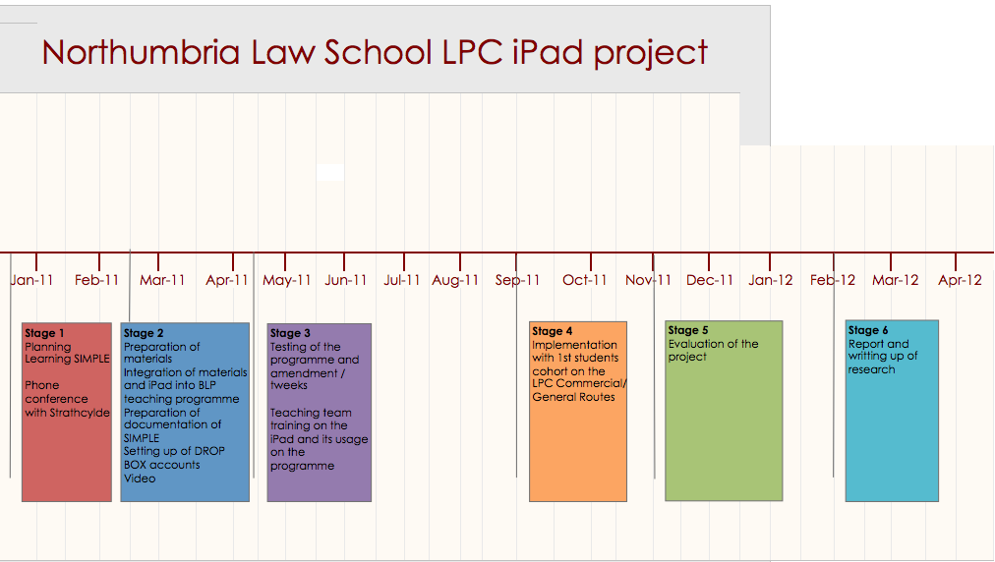

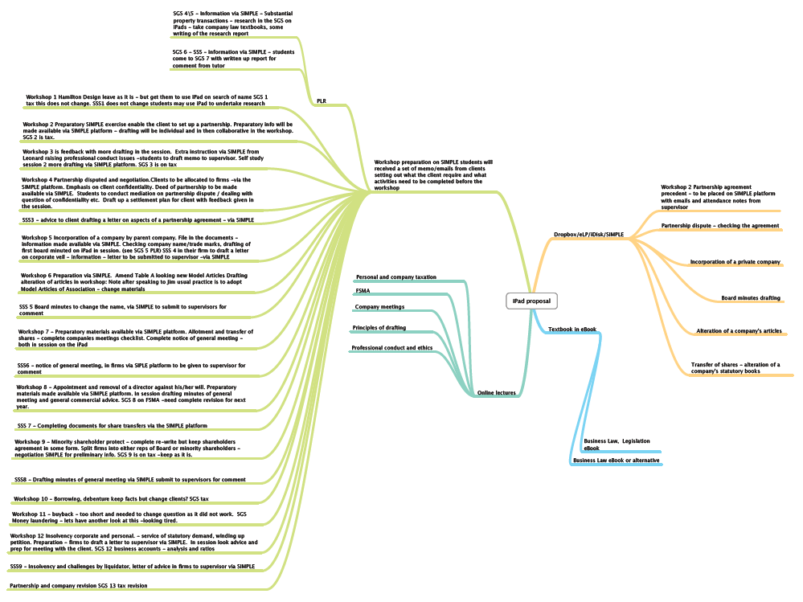
Appendix 2: Basic simulation design outline

